Garden Scavenger Hunt
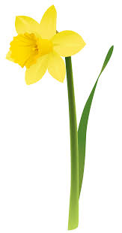
Cross off the items when you have found them!

Grass | Flower
Tree | Spider
Rock | Bird
Insect | Stick
Green leaf | Tree bud
Cloud | Water
Soil | Butterfly
Brown leaf | Sun

