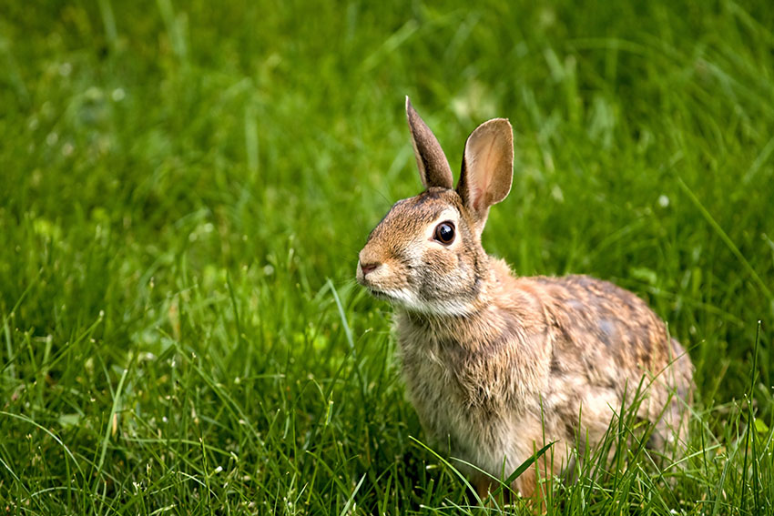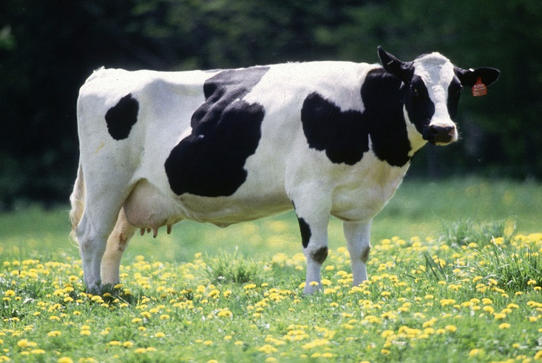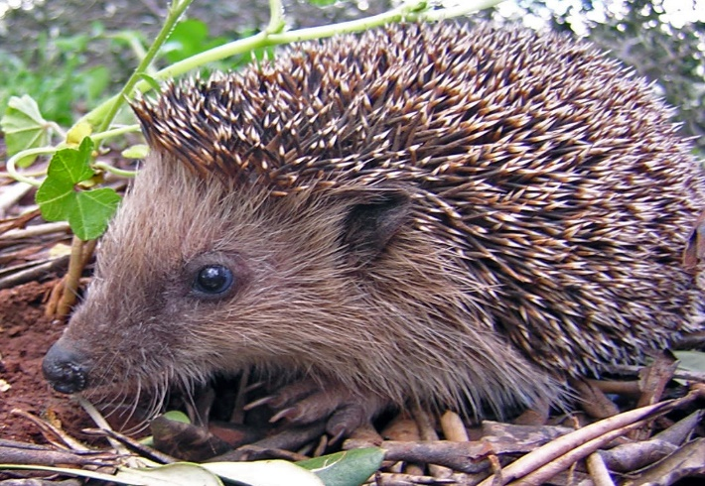 Animal ID

Name: Cow

Species: 1,000

Diet: grass and hay

Age length: 18-22 years

Name: Hedgehog

Species: 17

Diet: worms and insects

Age length: 2-5 years

Name: Rabbit

Species: 30

Diet: grass

Age length:1-12 years