**WEATHER**

 

**Across**

1. Flashes of light in the sky during a storm.

3. This ‘booms’ in the sky during a storm.

5. Light rain.

6. Water that falls from the sky.

7. Ice crystals that fall from the sky.

**Down**

2.A storm with very strong winds.

3. When this is low it is cold, when it is high it is hot.

4. These are made from water vapour.

6. This can appear in the sky after it rains.

8. This might blow off your hat.

**INSECTS**

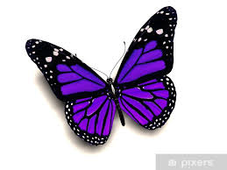

**Across**

2. Has 8 legs and makes a web.

3. I transform into a butterfly.

6. Flying insect that starts out at a caterpillar.

**Down**

1. Red beetle with black spots.

2. I carry my home on my back.

4. I live in a colony called a hill or mound.

5. I’m long and thin and live in soil.

6. I make honey.

**SPRING**



**Across**

2. Flowers which you can make into chains.

4. Pink and white flowers that grow on trees.

7. These are green and grow on trees.

8. Birds build these to lay eggs in.

**Down**

1. Baby sheep born in spring.

3. You might see this in ponds. They grow into frogs.

5. We plant these to grow fruit and vegetables.

6. Yellow spring flowers.

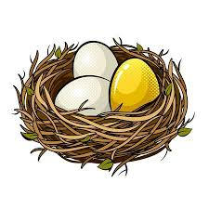

**Animals**

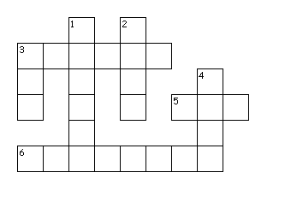

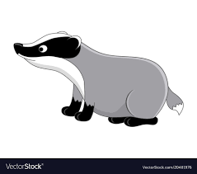

**Across**

3. A furry animal with a big flat tail and large teeth. It uses its teeth to cut wood and build dams.

5. A wild animal that looks like a dog with reddish- brown fur, a pointed face and ears and a thick tail.

6. Look a lot like mice, but with a furred tail.

**Down**

1. A wild animal with a white head with two black stripes on it.

2. A male has large branching horns.

3. a small flying creature that looks like a mouse with wings made of skin.

4. A small animal that looks like a mouse but has small ears and a short tail. Usually live in fields or near rivers.