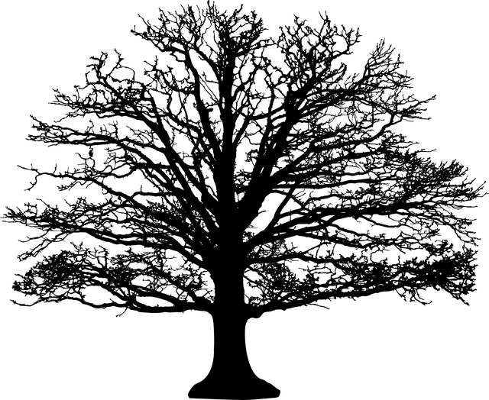

**Words to use:**

|  |
| --- |
| Trunk |
| Branch |
| Twig |
| Leaves |