Dandelion Jam



Ingredients

150g petals

750ml water

½ sliced orange

375g jam sugar

Juice from 1 medium lemon

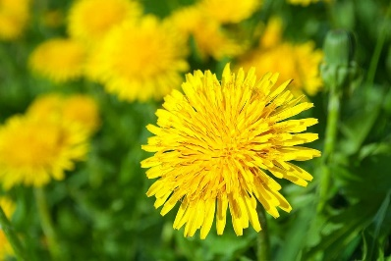

Rinse the dandelions well, pick off the head of the flower. Remove all of the green bits.

**Add the flowers and sliced orange to the water. Bring to the boil then simmer for 1 hour.**

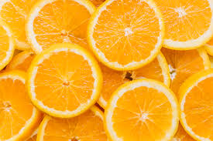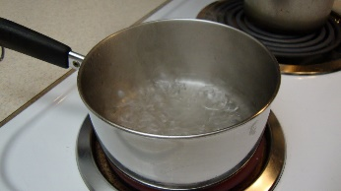

**Sieve the mixture. Add the sugar and lemon juice to the sieved liquid and return to the heat. Simmer the mixture for 30 minutes.**

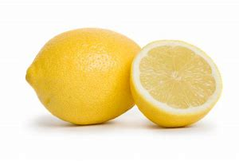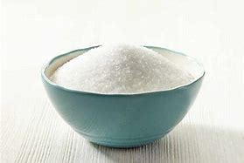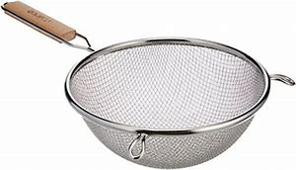

**Remove the mixture from the heat. Let it cool for 5 minutes then divide into sterilised jars. Let the jam cool before putting it in the fridge – it will keep for 3 – 4 months.**

**\***