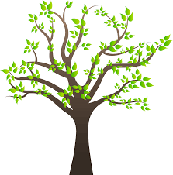
Trees Wordsearch
Find the hidden words

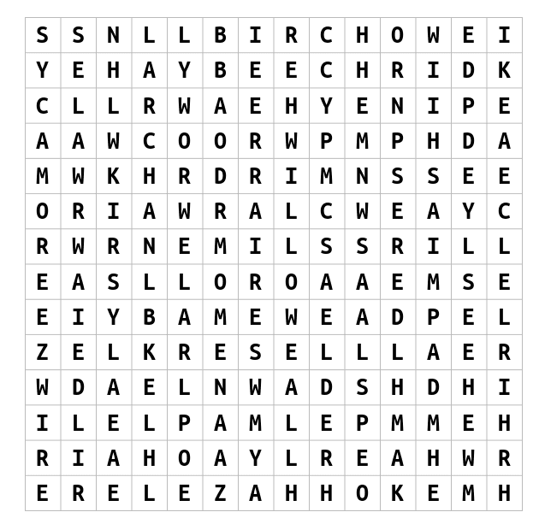

Pine | Oak | Ash | Larch | Beech
Hazel | Sycamore | Yew | Alder | Rowan
Maple | Lime | Birch | Willow | Elder

