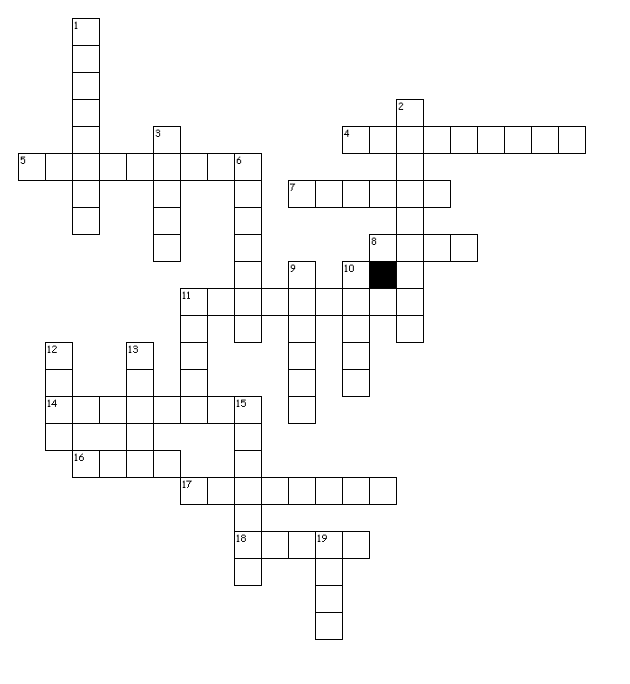
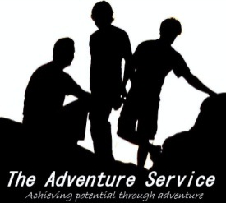
Weather
SUMMER | BLIZZARD
HOT | FROSTY
FALL | WINDY
COLD | RAIN
NIGHT | WARNINGS
HEATWAVE | BLACKOUTS
SNOW | TORNADOS
STORMS | HUMID
ICY | HURRICANE
FREEZING | WARM

Fit the words in the puzzle

FOOD | KNIFE
BUSHCRAFT | TREES
WILDERNESS | WOOD
FIRE | WATER
TOOLS | SHELTER
SURVIVAL | NATURE
Bushcraft 1
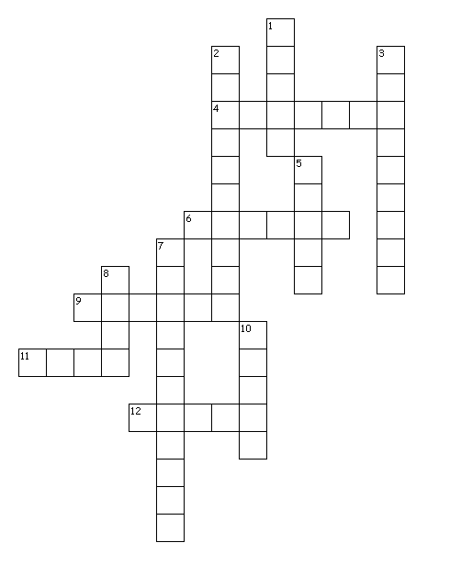

Fit the words in the puzzle
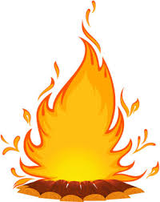

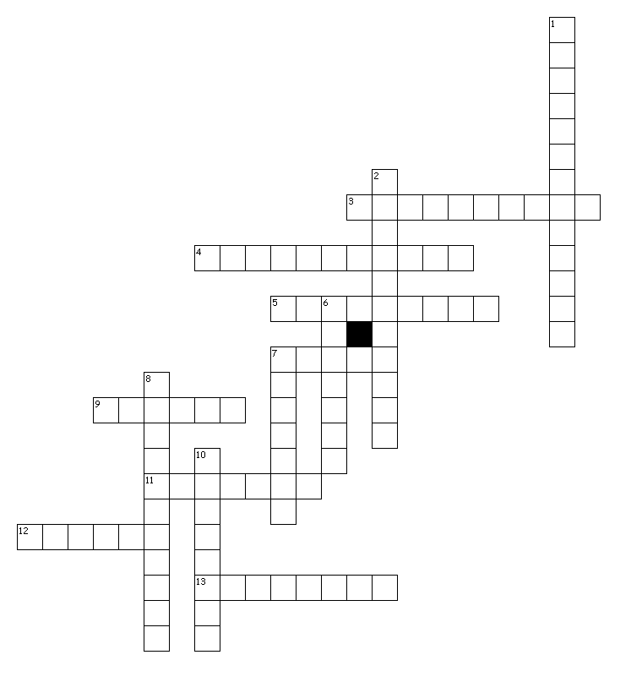
Butterflies

RINGLET | TORTOISESHELL
ORANGE | CLOUDED
FRITILLARY | SILVER
BRIMSTONE | ADMIRAL
HAIRSTREAK | SWALLOWTAIL
EMPEROR | SKIPPER
GRAYLING | COMMA

Fit the words in the puzzle

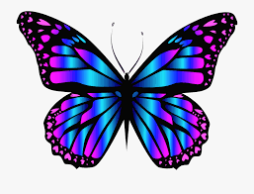

Spiders
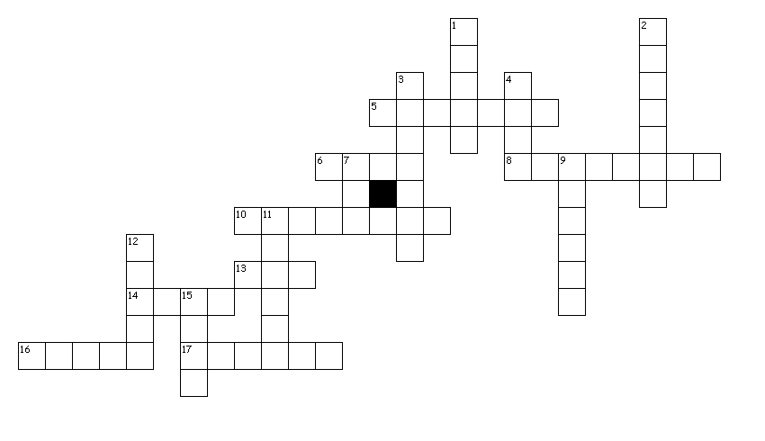

Fit the words in the puzzle

GARDEN | NURSERY
ZEBRA | WASP
BUZZING | MOUSE
PIRATE | SPITTING
ANT | RUNNING
WOLF | COMB
MONEY | ORB
SILK | JUMPING
LACE | SPITTING
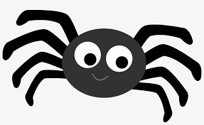

Fungi 1

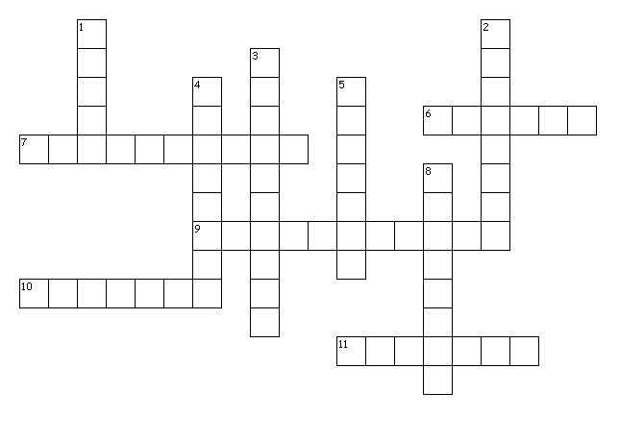

INKCAP | DRYADS
BLUSHER | SULPHUR
POLYPORE | PENNY
EARPICK | CHANTERELLE
PORCELAIN | MILKCAPS
FLYAGARIC

Fit the words in the puzzle

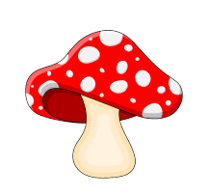

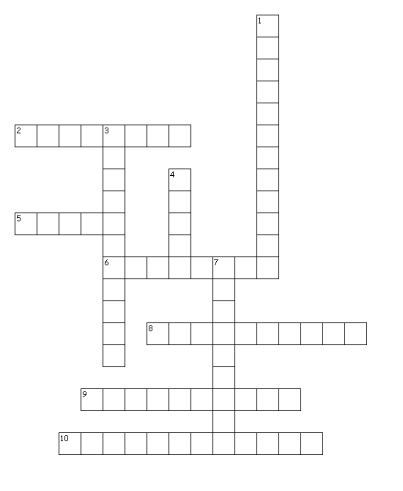
Fungi 2

Fit the words in the puzzle
STAGSHORN | PUFFBALL
HARES | EARTHTONGUES
EYELASH | CORAL
CANDLESNUFF | ORANGEPEEL
BIRDSNESTS | STINKHORN
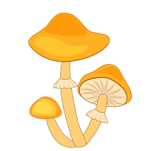

Trees 1

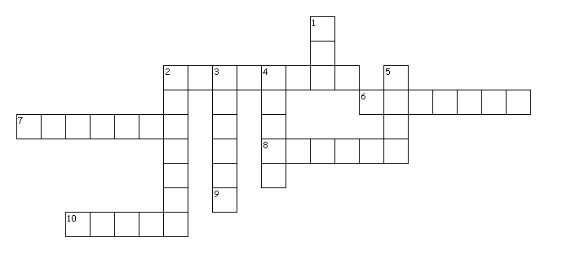

SPRUCE | JUNIPER
LARCH | HEMLOCK  Fit the words in the puzzle
YEW | SYCAMORE
PINE | MAPLE
CEDAR | FIR
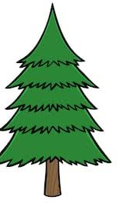

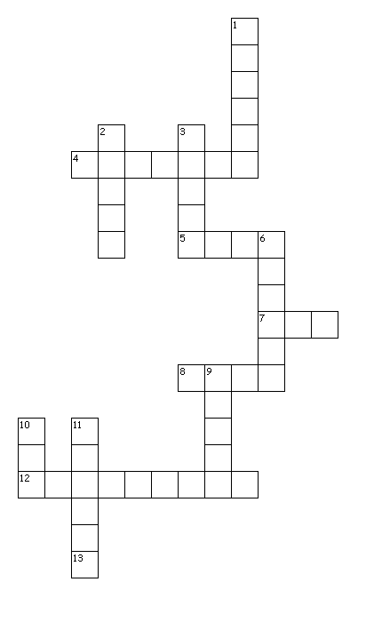
Trees 2

Fit the words in the puzzle

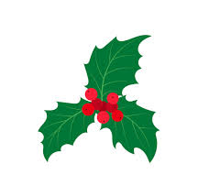
HAWTHORN | ASPEN
BEECH | HAZEL
POPLAR | LIME
ROWAN | ASH
ELDER | HOLLY
OAK | ELM

Trees 3

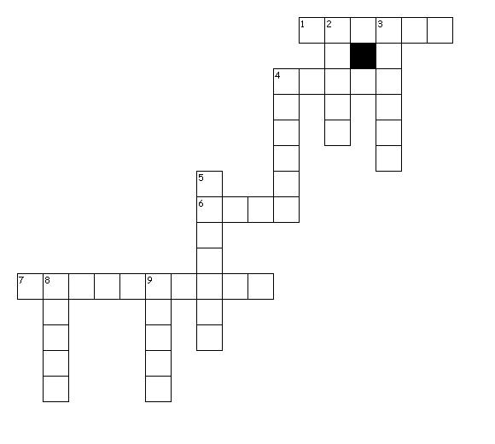

Fit the words in the puzzle

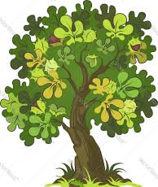
POPLAR | BIRCH
LARCH | CHERRY
ALDER | APPLE
WHITEBEAM | ASPEN
OAK | HAZEL

Trees 4 – Pines, Firs, Spruces and Oaks
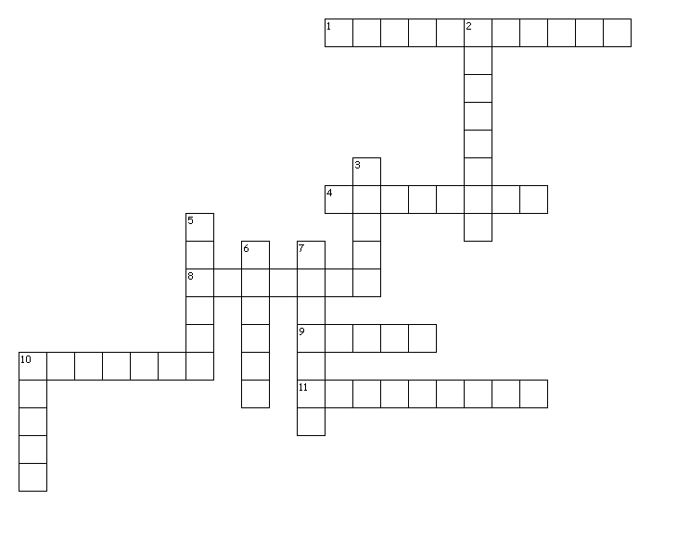

Fit the words in the puzzle
GRAND | SCOTS
NORWAY | CORSICAN
SITKA | PEDUNCULATE
TURKEY | LODGEPOLE
DOUGLAS | SESSILE
HOLM | NOBLE

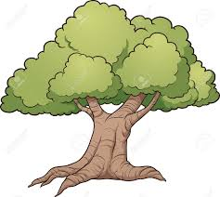

Archery
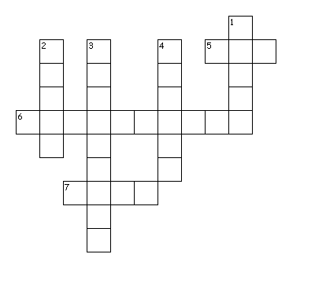

Fit the words in the puzzle

TARGET | UPPERLIMB
LOWERLIMB | STRING
NOCK | REST
RISER | BOW
SHAFT | ARROW
FLETCHING | PILE

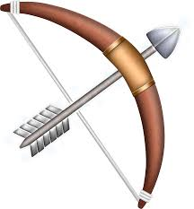

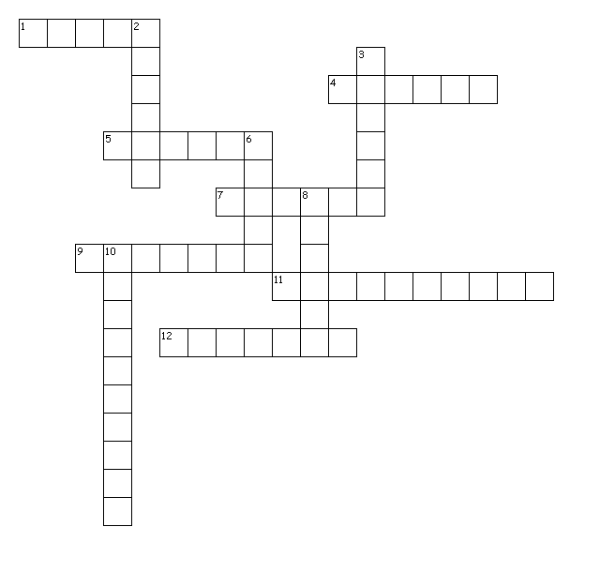
Bike Parts

Fit the words in the puzzle

TYRE | HANDLEBARS
INNERTUBE | FORKS
VALVE | SADDLE
CRANKS | SPOKES
LIGHTS | HELMET
GRIPS | PEDALS

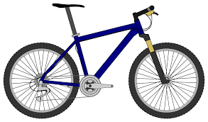

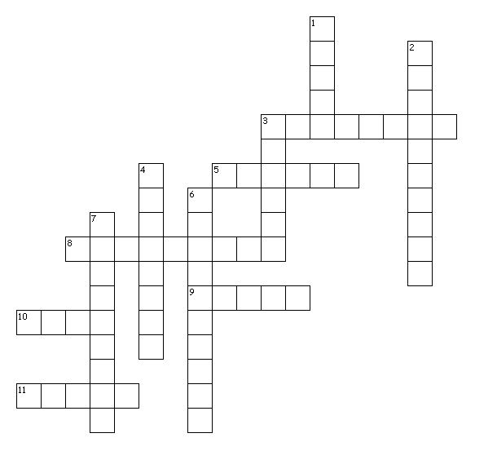
Bushcraft 2

Fit the words in the puzzle
SHELTER | FLINT
KINDLING | FIRE
CORDAGE | GLOVES
WHITTLING | FILTERING
CHARCLOTH | KNIFE
SMOKE | TREES
 | 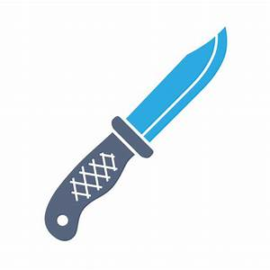

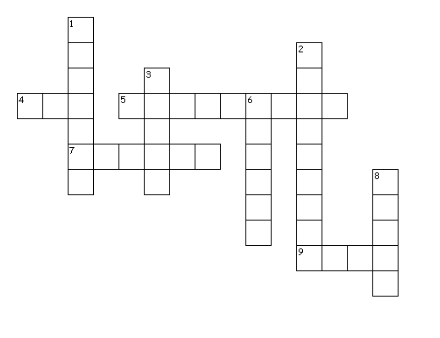
Navigation

Fit the words in the puzzle

BEARINGS | NORTH
SOUTH | EAST
WEST | COMPASS
HEADING | NEEDLE
MAP | 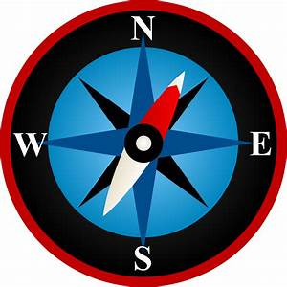  BASEPLATE

Circus
TRAPEZE | CLOWN
DANCE | RINGMASTER
SILKS | CLUBS
JUGGLING | BALLS
ARIAL | PLATES
BIGTOP | DIABLO
 | 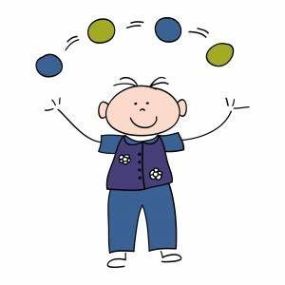

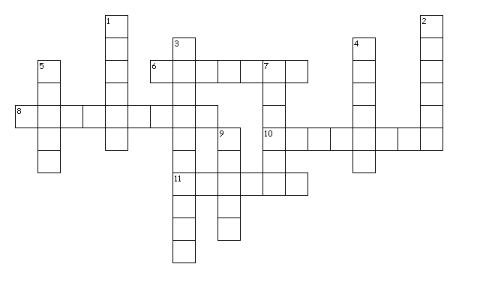

Fit the words in the puzzle

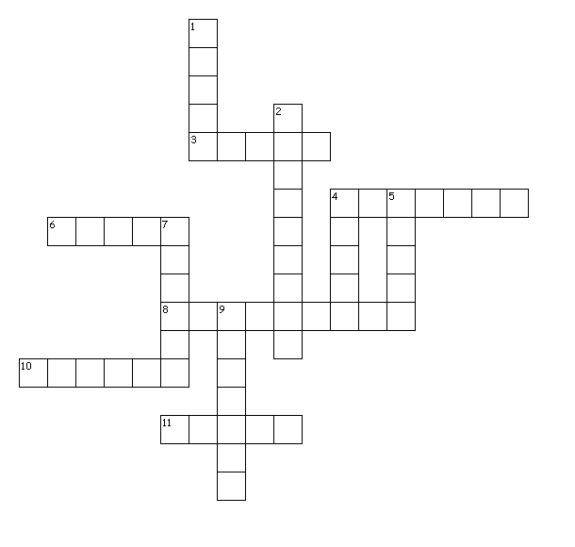
Climbing
GRIP | CLIMB
ROPE | CHALK
TRAVERSE | HOLDS
SHOES | HARNESS
ABSEIL | CARABINER
KNOTS | BELAY
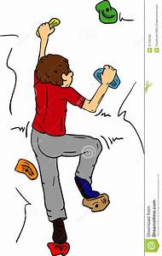

Fit the words in the puzzle

