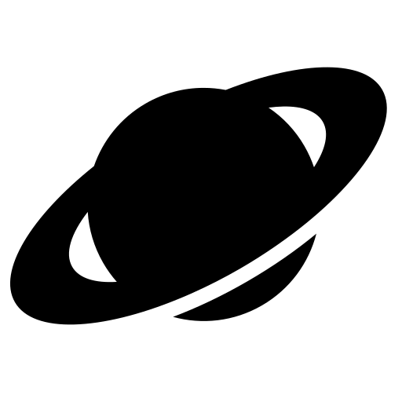
The Solar System

a | b | c | d | e | f | p | h | i | j | k | l
p | l | u | t | o | r | l | t | u | u | w | x
y | z | a | b | c | d | a | f | g | p | i | j
k | l | m | n | o | v | n | r | s | i | u | v
w | x | e | z | a | b | e | a | r | t | h | q
m | j | r | l | m | n | t | n | q | e | s | t
a | v | c | x | y | s | a | t | u | r | n | f
r | h | u | j | k | u | m | n | o | s | q | r
s | t | r | v | w | n | e | p | t | u | n | e
e | t | y | h | i | j | k | l | m | n | o | p
q | r | a | t | u | r | a | n | u | s | a | b
c | d | e | r | g | h | i | j | k | l | m | n
Mercury Venus Earth
Mars
Jupiter Saturn Uranus
Neptune
Pluto Star Planet
Sun

