Tree Crossword

Alder
Pine
Roots
Conker
Acorn
Blossom
Water
Deciduous
Bark
Leaves

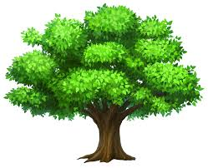
Across  2. Trees need this to survive?  6. What grows on trees?  9. Type of tree that sheds its leaves?  10. Seed of a horse chestnut tree? | Down  - These trees have needles?  3. what tree has cones and catkins?  4. Pink or white flowers that grow on a tree in spring?  5. Outer layer of a tree trunk?  7. What part of a tree grows underground?  8. Fruit of an oak tree?

