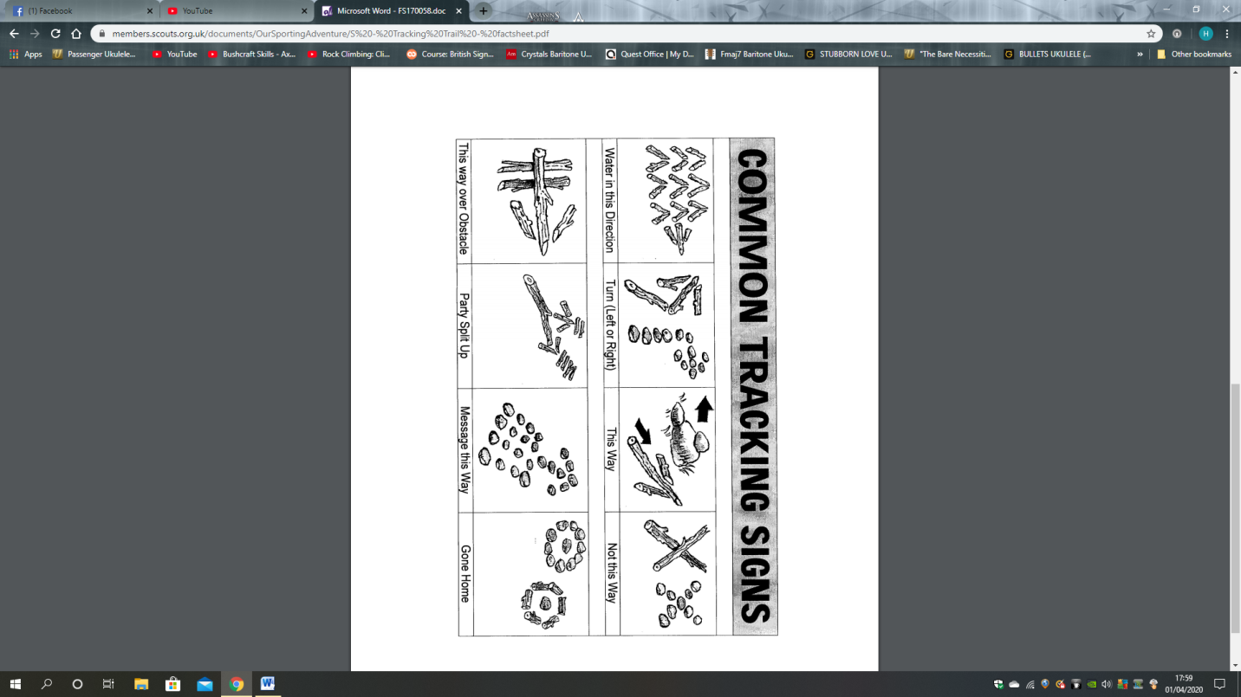

Make a secret stick or stone trail

**Using the key below make a stick or stone trail for others to follow, to make this challenge more exciting you could have a hidden prize at the end of the trail for the others to find**