Garden Bug Hunt

What is the weather like today?

What kind of habitats do you have in your garden?
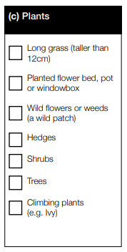
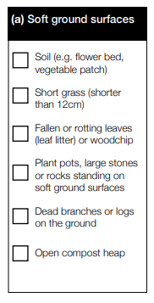
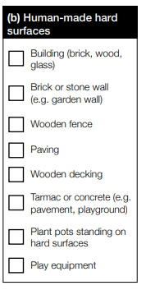

Timed Challenge!
No. of Legs | Type of Bugs |  | How Many Did You See?
 |  |  | Soft Ground (a) | Hard Ground (b) | Plants (c)
0 | Snails/Slugs | 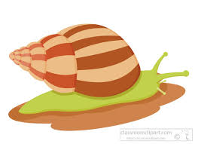
0 | Earthworks
6 | Beetles
6 | Bees/wasp
6 | Ants
6 | Butterflies/Moths
6 | Grasshoppers | 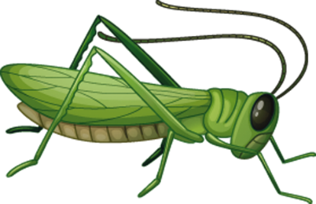
6 | Earwigs
6 | Flies
8 | Spiders
> 8 | Woodlice | 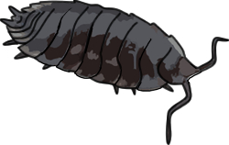
> 8 | Centipede/Milipedes
> 8 | Caterpillar

